**OPEN-SOURCE SOFTWARE DEVELOPMENT**

**ASSIGNMENT#2**

**SPRING-22**

**Submitted by:**

**Name:**

Hafiza Sabeeha Areej F2019065240

**Submitted on:**

**31/03/2022**

**Submitted to:**

**MUHAMMAD ASAD ARSHAD**

**University of Management and Technology**



**Logical and Physical Address in Operating System:**

Logical and physical address is that Logical address is generated by CPU in perspective of a program whereas the physical address is a location that exists in the memory unit.

**How Logical Address Map with Physical Address:**

The hardware device called Memory-Management Unit is used for mapping logical address to its corresponding physical address.

**STEPS TO MAP Logical Address Map with Physical Address:**

Base register **contains value of the smallest part of the physical address**. Limit register contains range of logical addresses.

* Each logical address must be less than the limit register.
* The value in the relocation register (Base Register) is added to every address generated by a user process at the time it is sent to memory.

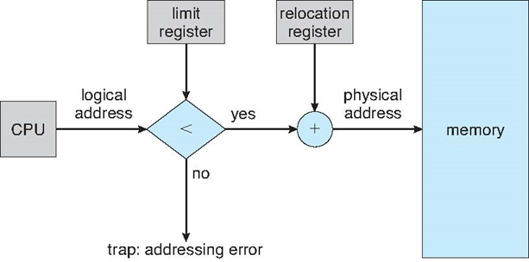

**THIS IS, How Logical Address Map with Physical Address:**

